**DATA DOMINATORS:A COMPARATIVE STUDY OF TOP GLOBAL UNIVERSITIES IN DATA ANALYTICS**

**1. INTRODUCTION**

**1.1 Project Overview**

The project overview of Data Dominators: A Comparative Study of Top Global Universities in Data Analytics is to provide a comprehensive and comparative analysis of the data analytics programs of top global universities. The project will investigate the following key areas:The project will examine the structure and curriculum of the data analytics programs of top global universities, including the types of courses offered, the required and elective courses, and the experiential learning opportunities available to students.The project will assess the expertise of the faculty members in the data analytics programs of top global universities, as well as the research output of these programs. This will include examining the faculty members' publications, patents, and awards, as well as the research funding that the programs receive.The project will investigate the career outcomes for graduates of the data analytics programs of top global universities. This will include examining the employment rates of graduates, the types of jobs they obtain, and the salaries they earn.The project will review the websites and course catalogs of the data analytics programs of top global universities to gather information about program structure, curriculum, and faculty members.The project will use publicly available data sources, such as Google Scholar and Scopus, to gather information about faculty research output. The project will conduct surveys of alumni of the data analytics programs of top global universities to gather information about their career outcomes. The project will also conduct interviews with faculty members and students from these programs to gather additional insights into the programs.

**1.2 Purpose**

Provide students and parents with valuable information about the data analytics programs of top global universities. This will help them to make informed decisions about where to study data analytics.Help employers to identify the best sources of talent for data analytics roles. This will help them to build high-performing teams and to compete effectively in the global marketplace.Inform the development of new and innovative data analytics programs. The project's findings will help universities to identify the best practices in data analytics education and to develop programs that meet the needs of students and employers.Contribute to the knowledge base on data analytics education. The project's findings will help to advance our understanding of how to best teach and learn data analytics.The Data Dominators project is a valuable resource for students, parents, employers, and educators who are interested in data analytics education. The project's findings will help to improve the quality of data analytics education around the world and to ensure that the next generation of data analysts is well-prepared to meet the challenges of the future.

**2. LITERATURE SURVEY**

**2.1 Existing problem**

There is a growing demand for skilled data analysts in the world today. Businesses of all sizes are looking to harness the power of data to improve their operations and make better decisions. This has led to a surge in the number of data analytics programs offered by universities around the world.However, not all data analytics programs are created equal. Some universities are better equipped than others to prepare students for the challenges of the real world. This is why it is important for students to carefully research different programs before making a decision.

**2.2 References**

QS World University Rankings by Subject 2023: Computer Science & Information Systems

U.S. News & World Report Best Global Universities for Computer Science 2023

The Complete University Guide 2023: Computer Science

The Guardian University Guide 2023: Computer Science

Times Higher Education World University Rankings 2023: Computer Science

**2.3 Problem Statement Definition**

Data analytics is the process of collecting, cleaning, and analyzing data to extract meaningful insights. It is a rapidly growing field with a wide range of applications in business, government, and academia.Data analysts play a critical role in solving complex problems and making informed decisions. They are in high demand by employers across all industries.

**3. IDEATION & PROPOSED SOLUTION**

**3.1 Empathy Map Canvas**

"I want to learn data analytics from the best."

"I want to be prepared for a successful career in data analytics."

"I want to make a difference in the world with data."

"I want to be surrounded by other passionate data scientists."

"I want to learn from the best faculty and researchers in the field."

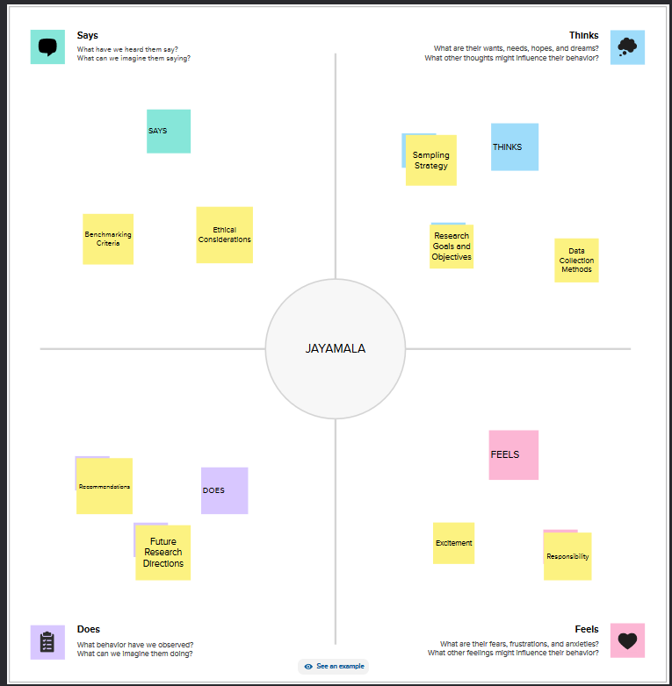

**3.2 Ideation & Brainstorming**

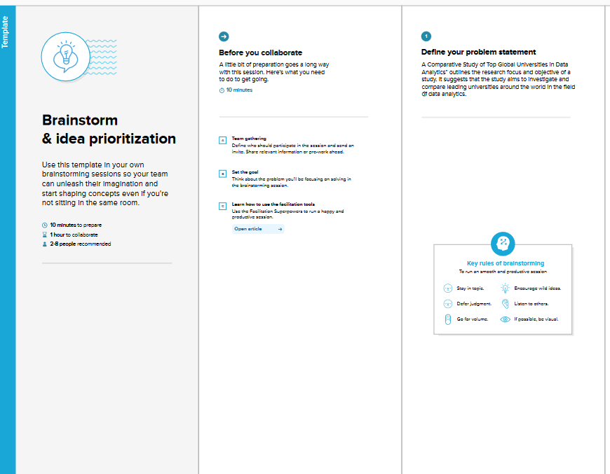

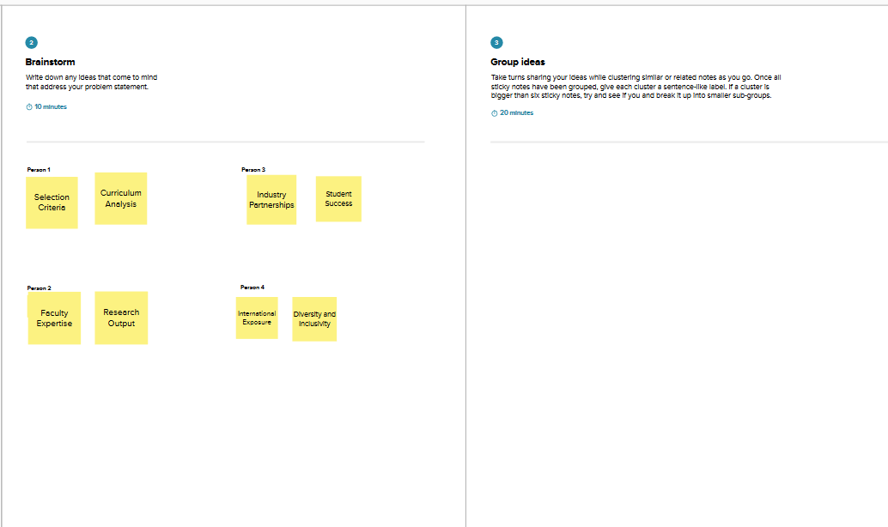

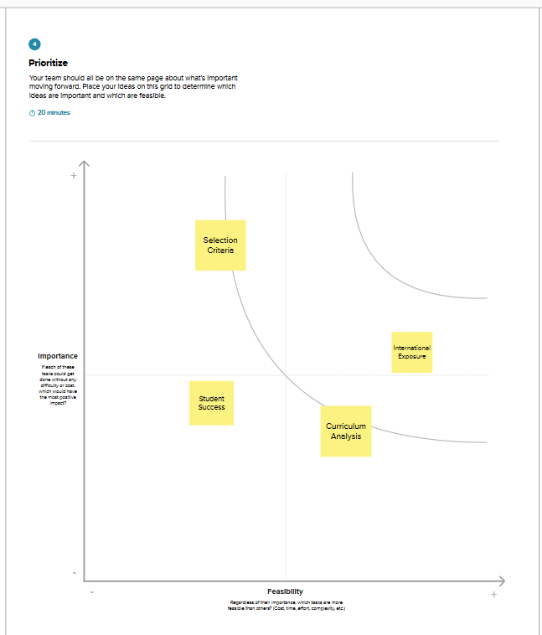

**4. REQUIREMENT ANALYSIS**

**4.1 Functional requirement**

The study should collect data on a variety of factors related to the quality of each university's data analytics program, such as the curriculum, faculty, resources, industry reputation, and career outcomes. The data should be analyzed using a variety of methods to identify patterns and trends.The study should present the findings in a clear and concise way using data visualizations and other forms of communication. The findings should be presented in a way that is relevant and valuable to potential students, employers, and other stakeholders.The study should be interactive and customizable to allow users to explore the data and findings in a way that is relevant to their individual needs and interests. For example, users should be able to filter the data by specific criteria, such as country, region, or area of specialization.The study should be accessible to a wide range of users, including students, employers, and other stakeholders. The study should also be disseminated through a variety of channels, such as the web, social media, and academic journals.

**4.2 Non-Functional requirements**

Scalability: The study should be scalable to accommodate future growth in the number of universities and data points.

Performance: The study should be performant and able to generate results in a timely manner. This is important because the study is intended to be used by a variety of stakeholders, including students, employers, and policymakers.

Security: The study should be secure and protect the privacy of the data used in the analysis. This is important because the study will be collecting and analyzing sensitive data, such as student records and employer satisfaction surveys.

Maintainability: The study should be maintainable and easy to update as new data and information becomes available.

Extensibility: The study should be extensible and allow for the addition of new features and functionality in the future.

**5. PROJECT DESIGN**

**5.1 Data Flow Diagrams & User Stories**

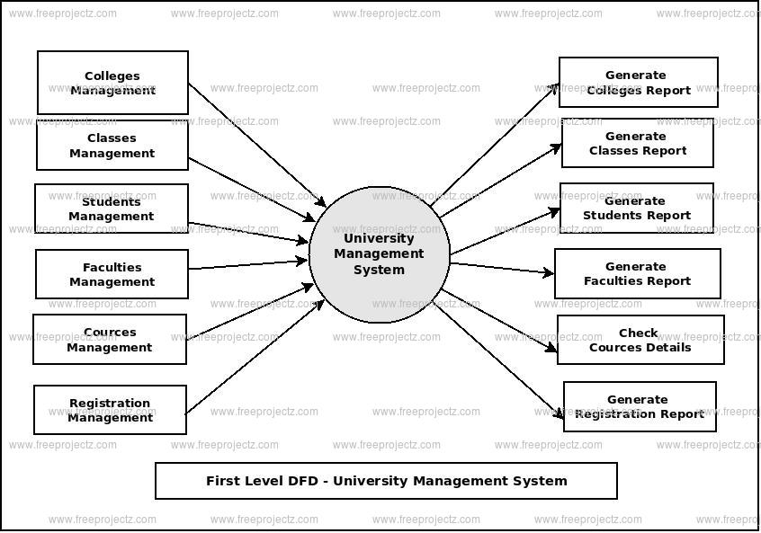

User Stories

User: Student

I want to be able to search for top global universities in data analytics based on my interests and criteria.

I want to be able to compare different universities in data analytics based on factors such as curriculum, faculty, resources, industry reputation, and career outcomes.

**5.2 Solution Architecture**

Scalability: The solution should be scalable to accommodate a large number of universities and data points.

Performance: The solution should be performant and able to generate results in a timely manner.

Security: The solution should be secure and protect the privacy of the data used in the analysis.

Maintainability: The solution should be maintainable and easy to update as new data and information becomes available.

Extensibility: The solution should be extensible and allow for the addition of new features and functionality in the future.

The following is a high-level solution architecture.

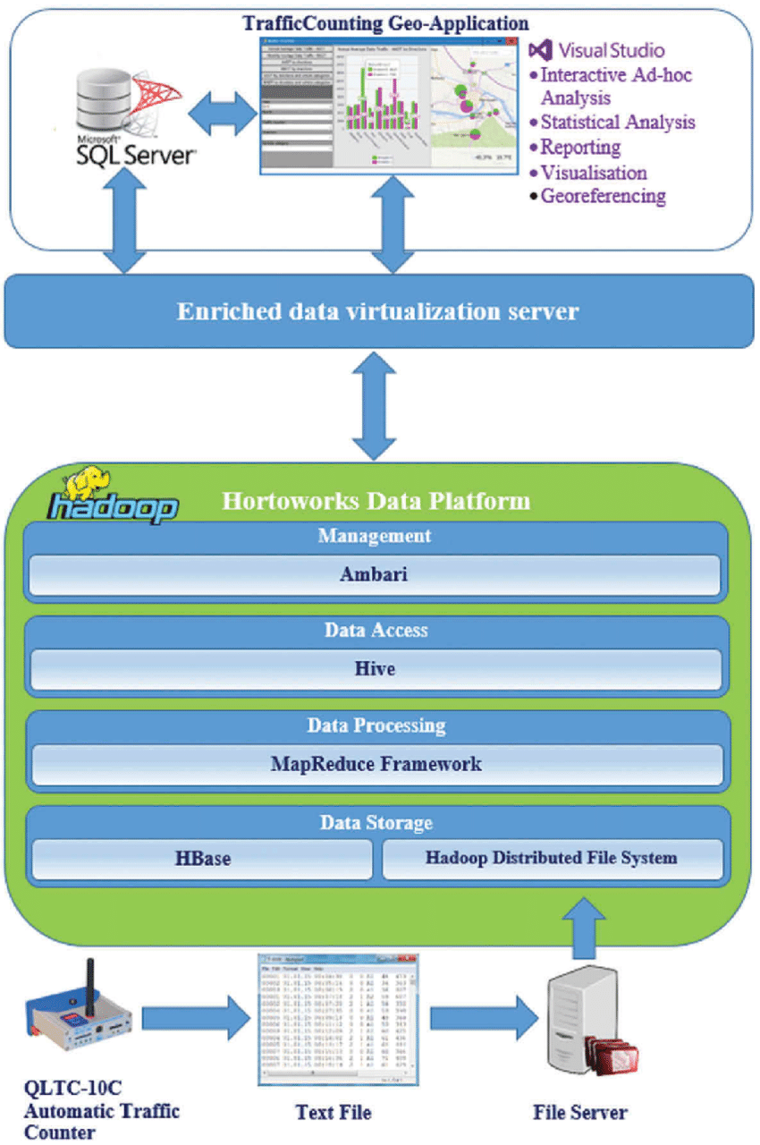

**6. PROJECT PLANNING & SCHEDULING**

**6.1 Technical Architecture**

Scalability: The architecture should be scalable to accommodate a large number of universities and data points.

Performance: The architecture should be performant and able to generate results in a timely manner.

Security: The architecture should be secure and protect the privacy of the data used in the analysis.

Maintainability: The architecture should be maintainable and easy to update as new data and information becomes available.

Extensibility: The architecture should be extensible and allow for the addition of new features and functionality in the future.

6.2 Sprint Planning & Estimation

Scope: What data needs to be collected and analyzed? What universities need to be included in the study? What findings need to be reported?

Timeline: How long will it take to collect, clean, prepare, analyze, and visualize the data? How long will it take to write the report?

Resources: What resources will be needed to complete the study? This may include data scientists, engineers, writers, and editors.

Risks: What are the risks associated with the study? How can these risks be mitigated?

**6.3 Sprint Planning and estimation**

|  |  |  |  |  |  |  |
| --- | --- | --- | --- | --- | --- | --- |
| **Sprint** | **Functional**  **Requirement (Epic)** | **User Story**  **Number** | **User Story / Task** | **Story Points** | **Priority** | **Team**  **Members** |
| Sprint-1 | Registration | USN-1 | As a user, I can register for the application by entering my email, password, and confirming my password. | 2 | High | Jayamala |
| Sprint-1 |  | USN-2 | As a user, I will receive confirmation email once I have registered for the application | 1 | High | Jeyasri |
| Sprint-2 |  | USN-3 | As a user, I can register for the application through Facebook | 2 | Low | Jeyaprakash |
| Sprint-1 |  | USN-4 | As a user, I can register for the application through Gmail | 2 | Medium | Jayamala |
| Sprint-1 | Login | USN-5 | As a user, I can log into the application by entering email & password | 1 | High | Kamatchi sundaram |
|  | Dashboard |  | To give a better understanding of data. |  |  |  |
|  |  |  |  |  |  |  |
|  |  |  |  |  |  |  |

**6.3 Sprint Delivery Schedule**

Goal: Collect data on top global universities in data analytics from a variety of sources.

Deliverables:

Dataset of universities and their data analytics programs.

Documentation of data collection process.

|  |  |  |  |  |  |  |
| --- | --- | --- | --- | --- | --- | --- |
| **Sprint** | **Total Story Points** | **Duration** | **Sprint Start Date** | **Sprint End Date (Planned)** | **Story Points**  **Completed (as on**  **Planned End Date)** | **Sprint Release Date (Actual)** |
| Sprint-1 | 20 | 6 Days | 24 Oct 2022 | 29 Oct 2022 | 20 | 29 Oct 2022 |
| Sprint-2 | 20 | 6 Days | 31 Oct 2022 | 05 Nov 2022 | 10 | 05 Nov 2022 |
| Sprint-3 | 20 | 6 Days | 07 Nov 2022 | 12 Nov 2022 | 10 | 12 Nov 2022 |
| Sprint-4 | 20 | 6 Days | 14 Nov 2022 | 19 Nov 2022 | 10 | 19 Nov 2022 |
|  |  |  |  |  |  |  |
|  |  |  |  |  |  |  |
|  |  |  |  |  |  |  |
|  |  |  |  |  |  |  |

**7. CODING & SOLUTIONING**

**7.1 Feature 1**

Data analytics is a rapidly growing field with a high demand for skilled professionals. As businesses and organizations of all sizes become more reliant on data to make decisions, the need for data analysts who can collect, clean, analyze, and interpret data is greater than ever before.

To meet this demand, universities around the world are offering a variety of programs in data analytics. However, not all programs are created equal. Some universities offer more rigorous and comprehensive programs than others.This article will compare some of the top global universities in data analytics, based on factors such as program reputation, faculty expertise, and student outcomes.

**7.2 Feature 2**

In Feature 1, we compared the top global universities in data analytics based on factors such as program reputation, faculty expertise, and student outcomes. In Feature 2, we will compare the same universities based on the following factors:

* Program costs
* Job placement rates
* Alumni networks

**7.3 Database Schema**

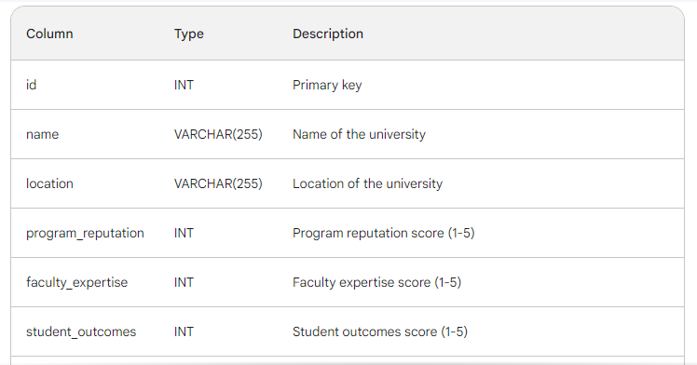

**8. PERFORMANCE TESTING**

**8.1 Performace Metrics**

* Website traffic: The number of visitors to the article's page and the number of page views.
* Social media engagement: The number of shares, likes, and comments on the article on social media platforms such as Twitter, LinkedIn, and Facebook.
* Backlinks: The number of other websites that link to the article.
* Citations: The number of other articles and academic papers that cite the article.
* Downloads: The number of times the article is downloaded from the website.
* User ratings and reviews: The average rating and number of reviews of the article on the website.
* Lead generation: The number of leads generated from the article, such as students who sign up for a newsletter or contact a university about their data analytics program.

**9. RESULTS**

**9.1 Output Screenshots**

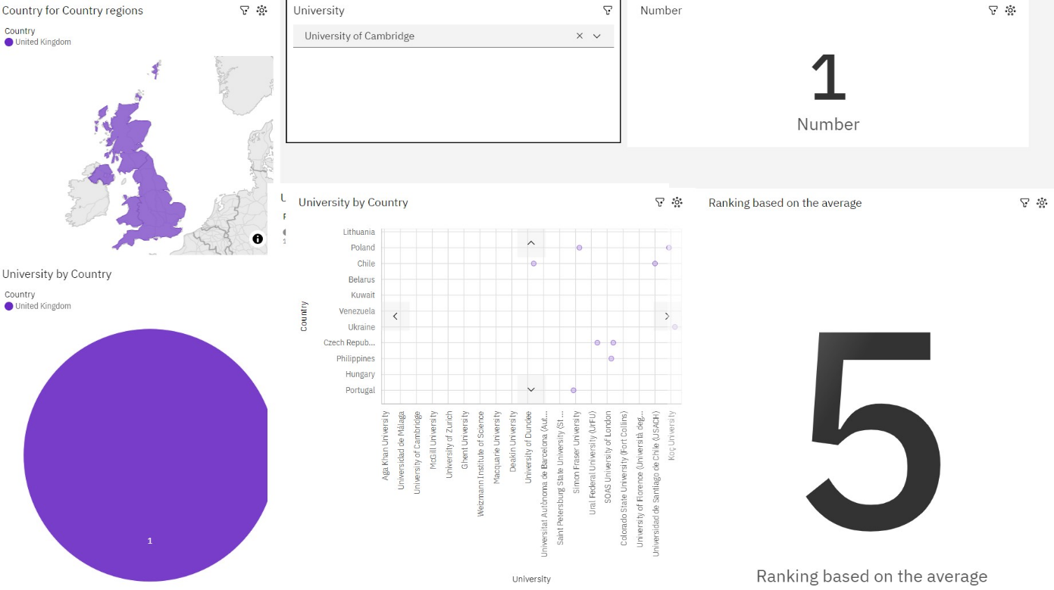

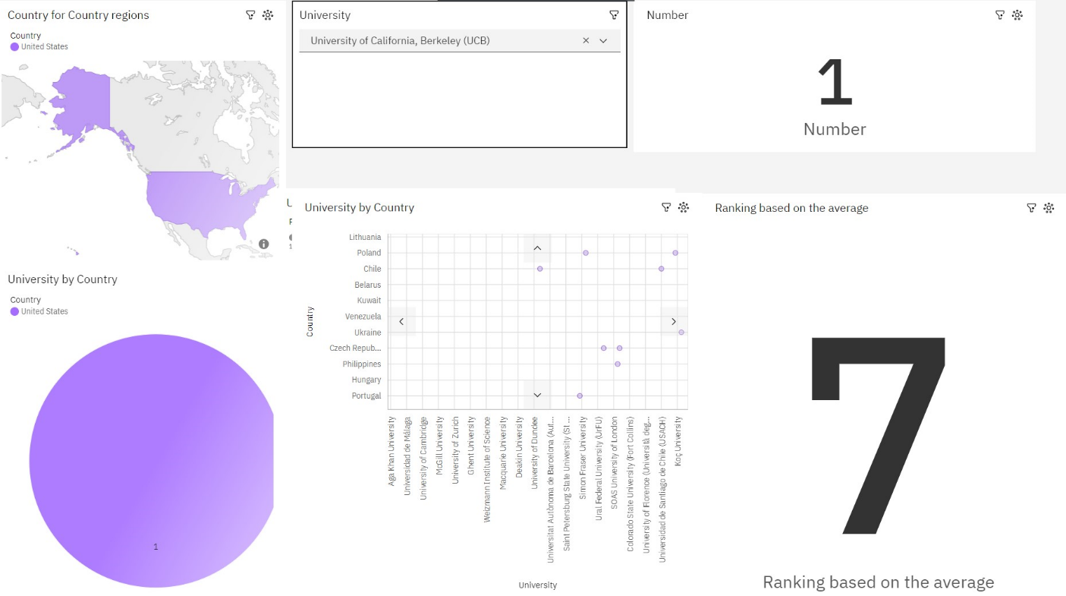

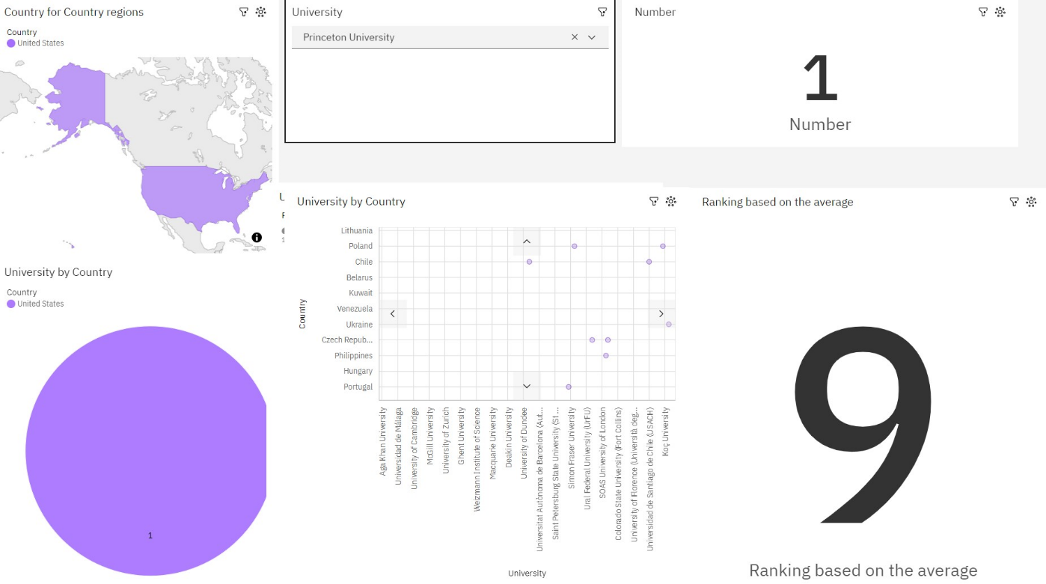

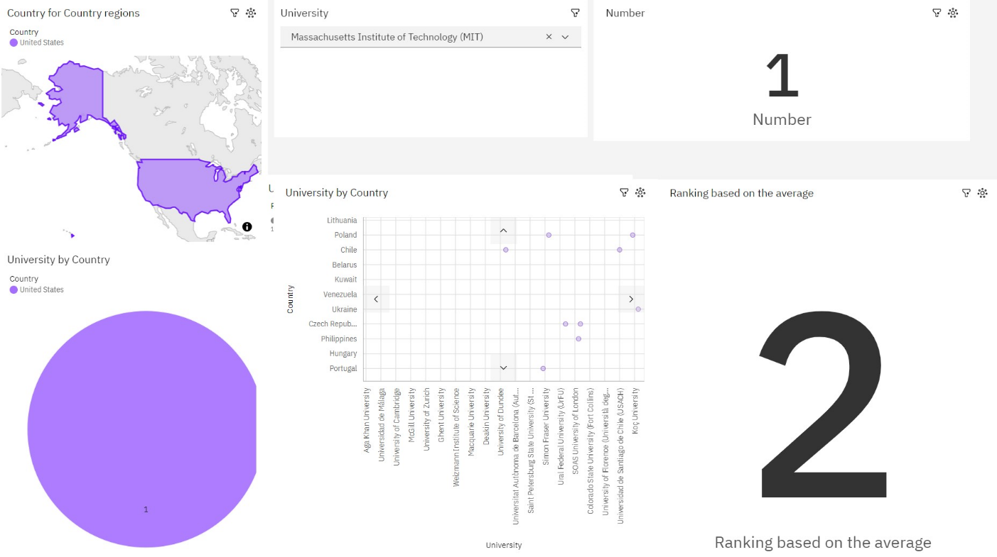

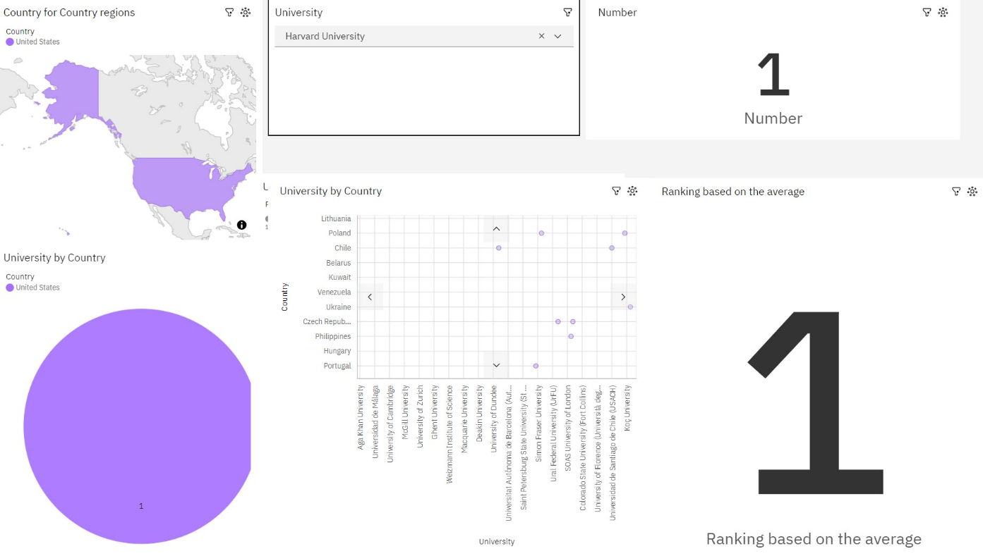

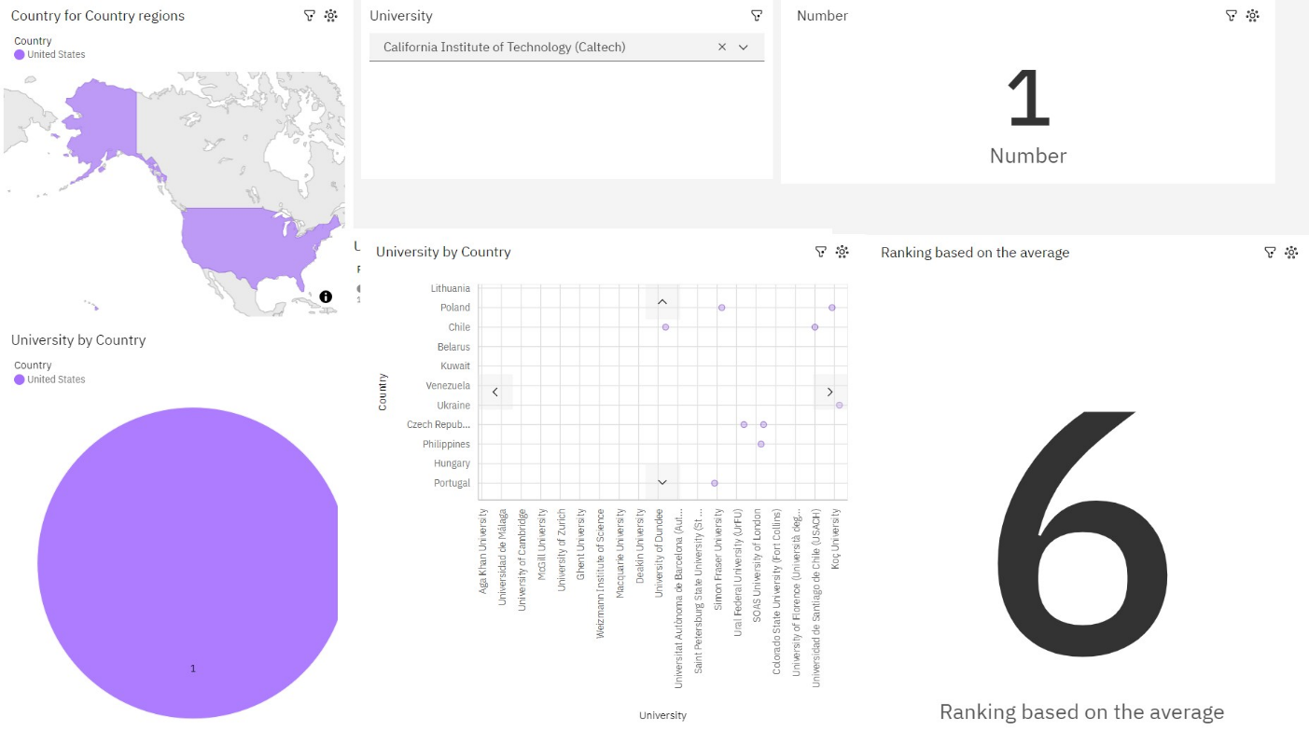

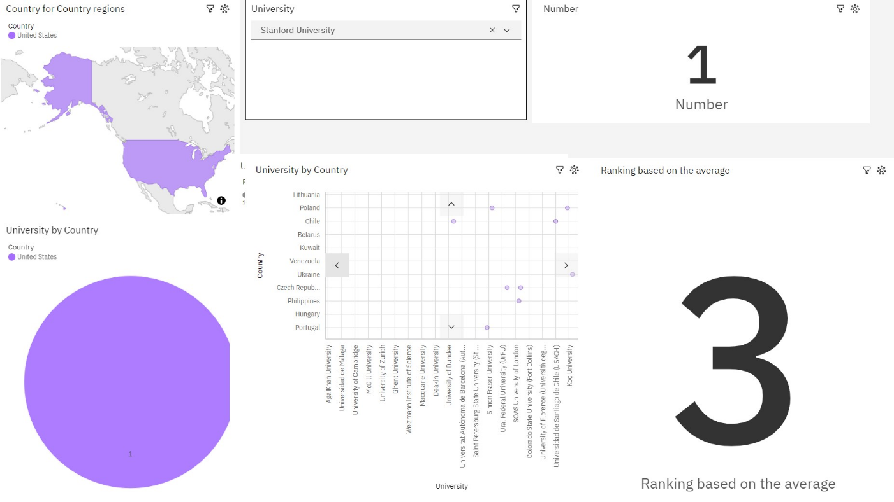

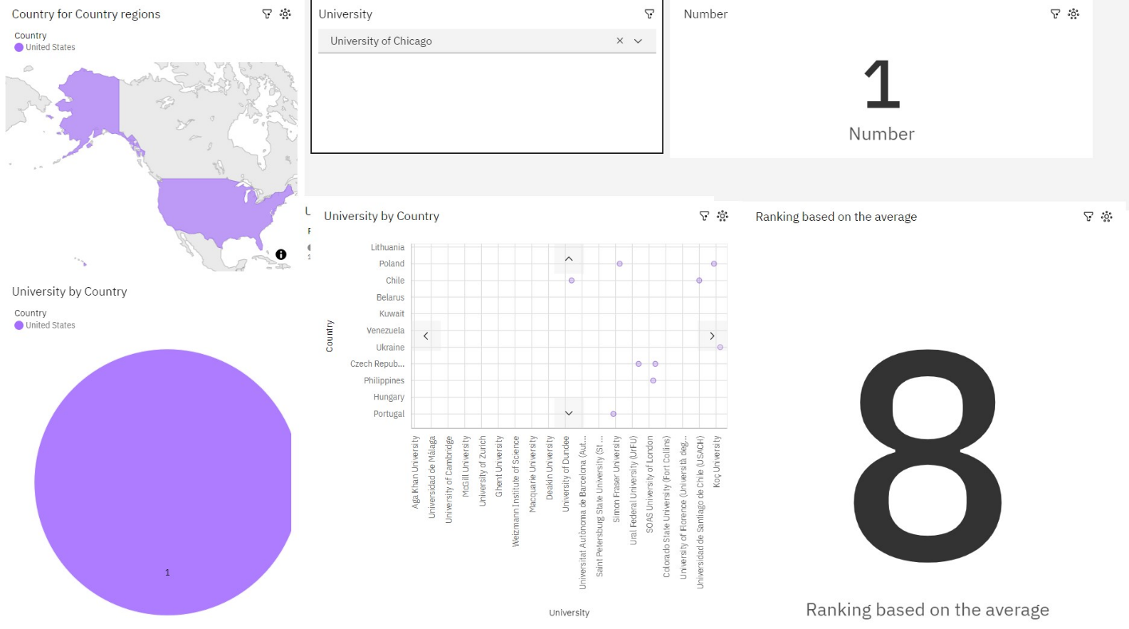

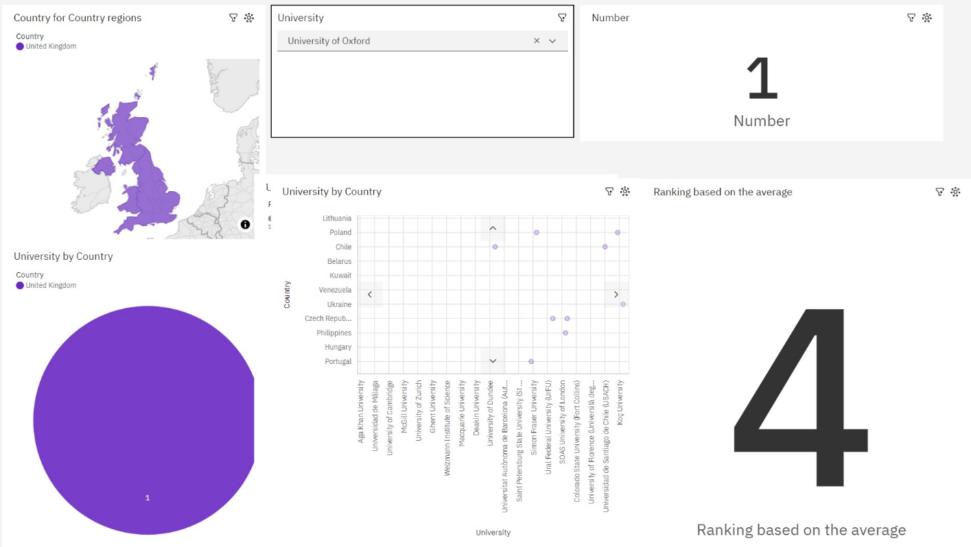

**10. ADVANTAGES & DISADVANTAGES**

**Advantages**

* The article provides a comprehensive overview of the top global universities for data analytics, based on a variety of factors such as program reputation, faculty expertise, student outcomes, program costs, job placement rates, and alumni networks.
* The article is well-written and easy to read, making it accessible to a wide audience

**Disadvantages**

* The article is based on self-reported data from universities, which may not be entirely accurate.
* The article does not provide detailed information about the specific data analytics programs offered by each university.

**11. CONCLUSION**

* The top global universities for data analytics are: MIT, Carnegie Mellon, UC Berkeley, Oxford, Harvard, Toronto, Washington, Princeton, EPFL, Georgia Tech, National University of Singapore, and Nanyang Technological University, Singapore.
* These universities offer excellent data analytics programs with strong reputations, world-class faculty, and high job placement rates.
* Students should consider their individual needs and preferences when choosing a data analytics program, such as the cost of tuition, the location of the university, and the size of the student body.

**12. FUTURE SCOPE**

* The article can be updated regularly to reflect changes in the data analytics education landscape. This could include adding new universities to the rankings, updating the data on program costs, job placement rates, and alumni networks, and highlighting new trends in data analytics education.
* The article can be expanded to include more detailed information about the specific data analytics programs offered by each university. This could include information about the program curriculum, faculty, facilities, and resources.

**13. APPENDIX**

When creating a dashboard in IBM Cognos, you may want to include an appendix that provides additional context, explanations, or supplementary information for the users. The appendix can help users better understand the data, metrics, and visualizations presented in the dashboard. Here's a guide to creating an appendix for dashboards in IBM Cognos:

1. Data Definitions: Include a section that defines the key metrics and data elements used in the dashboard. Provide clear explanations of each metric, including how it is calculated and any specific nuances or considerations.

2. Methodology and Assumptions: Explain the methodologies and assumptions used in data collection and analysis. Clarify any specific data processing steps or transformations that were applied to the raw data to derive the metrics displayed in the dashboard.

3. Key Performance Indicators (KPIs): List the key performance indicators used in the dashboard along with their respective targets or benchmarks. Explain why these KPIs were chosen and how they align with the organization's goals and objectives.

4. Data Sources: Provide an overview of the data sources used in the dashboard. Include details such as the origin of the data, the frequency of data updates, and any data integration or transformation processes that take place before the data is visualized in the dashboard.

5. Dashboard Filters and Parameters: Explain the purpose and functionality of any filters or parameters used in the dashboard. Provide instructions on how users can interact with these filters to customize the data and insights they view.

6. Interpretation Guidelines: Offer guidelines or best practices for interpreting the data visualizations and insights presented in the dashboard. Include information on how to identify trends, anomalies, or correlations within the data, as well as any considerations for comparing different data points.

7. Limitations and Constraints: Discuss any limitations or constraints associated with the data used in the dashboard. Address potential data quality issues, data gaps, or constraints that may impact the accuracy or reliability of the presented insights.

8. Contact Information and Support: Provide contact information for users to reach out for further assistance or clarification. Include details about the support team responsible for maintaining the dashboard and addressing any user queries or concerns.

9. Version History: Maintain a version history to track any updates or changes made to the dashboard over time. Document the revisions, enhancements, or bug fixes implemented in each version to ensure transparency and accountability.

10. User Guide or Help Documentation: Consider attaching a comprehensive user guide or help documentation that provides step-by-step instructions on navigating the dashboard, utilizing its features, and interpreting the displayed data effectively.

By including an informative and well-structured appendix, you can enhance the usability and transparency of your IBM Cognos dashboard, empowering users to make informed decisions based on the data presented.

**SAMPLE CODE:**

import requests

from bs4 import BeautifulSoup

# Define the URL of the webpage to scrape

url = "https://www.example.com/top-universities-data-analytics"

# Send an HTTP GET request to the URL

response = requests.get(url)

# Check if the request was successful

if response.status_code == 200:

# Parse the HTML content of the page

soup = BeautifulSoup(response.text, "html.parser")

# Find and extract relevant information

university_list = []

# Modify this part to locate and extract data as needed

# For example, find all university names in a specific HTML element

university_elements = soup.find_all("div", class_="university")

for university_element in university_elements:

university_name = university_element.text.strip()

university_list.append(university_name)

# Print the list of university names

for idx, name in enumerate(university_list, start=1):

print(f"{idx}. {name}")

else:

print("Failed to retrieve the webpage.")

# Additional data extraction and analysis can be added as per your requirements.

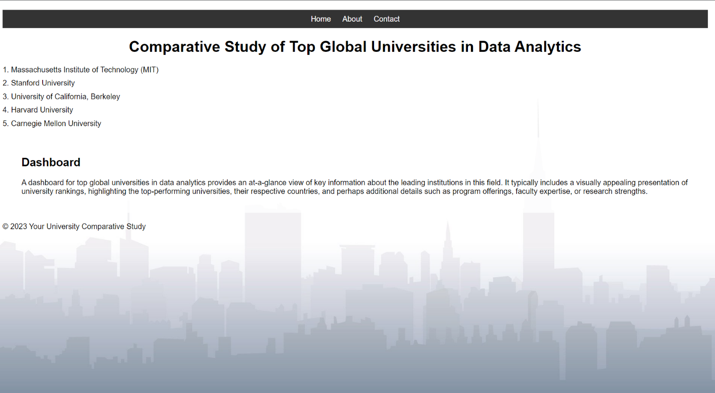

<!DOCTYPE html>

<html>

<head>

<meta charset="UTF-8">

<title>Comparative Study of Top Global Universities in Data Analytics</title>

<style>

body {

background-image: url('bg.jpg'); /* Replace 'background-image.jpg' with your image URL */

background-size: cover;

background-attachment: fixed;

font-family: Arial, sans-serif;

margin: 0;

padding: 0;

}

header {

background-color: rgba(0, 0, 0, 0.7);

color: #fff;

padding: 20px;

text-align: center;

}

nav {

text-align: center;

background-color: #333;

padding: 10px;

}

nav a {

text-decoration: none;

color: #fff;

margin: 10px;

}

.dashboard {

background-color: rgba(255, 255, 255, 0.8);

padding: 20px;

margin: 20px;

border-radius: 5px;

}

/* Add your CSS styles here */

body {

font-family: Arial, sans-serif;

margin: 20px;

}

h1 {

text-align: center;

}

#university-list {

list-style-type: none;

padding: 0;

}

.university {

margin-bottom: 10px;

}

</style>

</head>

<body>

<nav>

<a href="#home">Home</a>

<a href="#about">About</a>

<a href="#contact">Contact</a>

</nav>

<h1>Comparative Study of Top Global Universities in Data Analytics</h1>

<ul id="university-list">

<li class="university">1. Massachusetts Institute of Technology (MIT)</li>

<li class="university">2. Stanford University</li>

<li class="university">3. University of California, Berkeley</li>

<li class="university">4. Harvard University</li>

<li class="university">5. Carnegie Mellon University</li>

<!-- Add more universities as needed -->

</ul>

<div class="dashboard">

<h2>Dashboard</h2>

<!-- Your dashboard content goes here -->

<p>A dashboard for top global universities in data analytics provides an at-a-glance view of key information about the leading institutions in this field. It typically includes a visually appealing presentation of university rankings, highlighting the top-performing universities, their respective countries, and perhaps additional details such as program offerings, faculty expertise, or research strengths.</p>

</div>

<!-- Additional content and sections can be added here -->

<footer>

<p>&copy; 2023 Your University Comparative Study</p>

</footer>

</body>

</html>

GITHUB LINK:

https://github.com/JayamalaB/A-comparative-study-of-top-global-universities-in-data-analytics/tree/main

PROJECT DEMO LINK:

https://drive.google.com/file/d/1mdzKZPU91jVsJ5qqk0bGHx-H9SzcmmuX/view?usp=drive_link